

**MINI PROJECT**

**ON**

**PARKING TICKET FARE CALCULATOR**

SUBMITTED BY – Amirtha katesa sai raj R

SFID - 105107

|  |  |  |
| --- | --- | --- |
| **S.no** | **TABLE OF CONTENTS** | **PAGE NO** |
| 1 | Problem statement | 2 |
| 2 | Project Description | 2 |
| 3 | Requirements Gathering | 3 |
| 4 | UML Diagram | 4 |
| 5 | Test Plan | 5 |
| 6 | Test Cases | 5 |
| 7 | Result | 6 |

**PROBLEM STATEMENT: -**

To create a fast and error free fare calculator for different vehicles parked in a parking with respect to its parked time.

**PROJECT DESCRIPTION: -**

Vehicle ticket fare calculator is an automated system that generates fare for a vehicle that has been parked in a parking space like malls, private companies, theaters, parks etc. It is a graphic free project that generates fare for different types of vehicles based on their entry and exit time (no of hours parked) with respect to a fixed rate. This project helps to minimize human errors and is also fast in generating fare with ease.

**REQUIREMENTS GATHERING:**

* Software Requirements:

*Code::Blocks*

* System Requirements:

*Linux*

*Windows*

* Programming Language:

*C Language*

* Functional Requirements:

Specifying the type of vehicle like Car, Motorcycle etc.

*Type of Vehicle*

Specifying the time parked like 1hours, 30minutes etc.

*Time Parked*

*Payment status*

Specifying and confirming payment status like cash or other payment methods.

**UML OF THE PROPOSED PROJECT:**

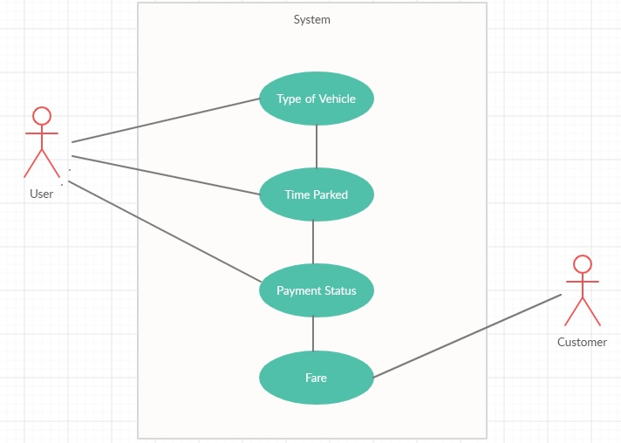

**TEST PLAN:**

|  |  |
| --- | --- |
| S.no | TEST OBJECTIVE |
| 1 | To check if all the inputs to be taken are displaying properly |
| 2 | To check if the system accepts the user inputs correctly |
| 3 | To check if the system is able to differentiate between the different types of vehicles |
| 4 | To check if the system generates correct fare for all types of vehicles with its parking time |
| 5 | To check if the system is able to find the payment method and produce the receipt to the customer |

**TEST CASES:**

|  |  |  |
| --- | --- | --- |
| TEST CASE | EXPECTED OUTPUT | RESULT |
| Checking the user input | System should take all the required inputs from user | System has taken the required inputs to generate ticket |
| Checking if the system is able to differentiate between vehicles | System should be able to acknowledge the type of vehicle | System has found out the type of vehicle |
| Checking if the system is able to take different parking times | System should be able to acknowledge the parking time | System has acknowledged the parking time |
| Checking if the system is able to provide a correct fare | System should be able to provide correct fare for different vehicles along with their parking time | System is able to provide correct for the vehicles parked |
| Checking if the system is able to provide receipt | System should verify payment status and provide receipt | System provides the receipt to the customer |

**RESULT:**

The proposed system is to provide ticket for vehicles parked in a parking space with their parking time. It is a fast and accurate fare calculator for the customers to avoid errors and waiting period for long time.